**LAPTOP REQUEST CATALOG ITEM**

# **Team Information**

**NM_ID: 2FEF42AC71685F292E64D45E22EAC524**

**Team ID**: NM2025TMID15879

Team Size: 4

**Team Leader:** HARISH.A

**Team Members:**  
1. BALAJI P  
2. KISHAN V  
3. SARAVANAN P

**Problem Statement**

# In many organizations, employees face difficulties when requesting laptops due to manual processes, lack of standardization, and unclear approval workflows. This leads to delays, miscommunication, and inefficiency in IT service delivery. Without a centralized system, tracking requests and ensuring timely fulfillment becomes a major challenge.

# **Objective**

The objective of this project is to design and implement a user-friendly Laptop Request Catalog in ServiceNow that enables employees to easily request laptops through an online portal. The catalog ensures standardized request submission, automated workflows, approval processes, and efficient tracking, thereby improving the overall IT service management and reducing manual effort.

**Skills:**

* Problem-Solving and Logical Thinking
* Project Documentation and Presentation
* Time Management and Task Prioritization
* Collaboration and Teamwork

**STEPS TO COMPLETE THE PROJECT:**

**Create Local Update Set**

1. Open service now.

2. Click on All >> search for local update set.

3. Click on new and update the laptop request.

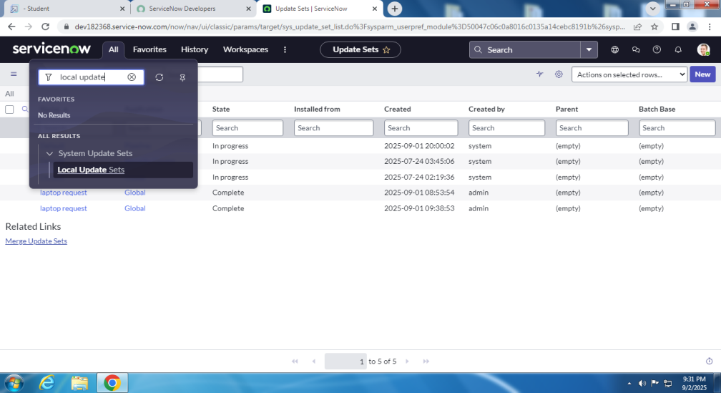

**Create Service Catalog Item**

1. Click on All >> service catalog(maintain items)

Fill the required details and create it.

2. add variables in it.

**Create Catalog Ui Policies**

In catalog ui policies,create a catalog item.

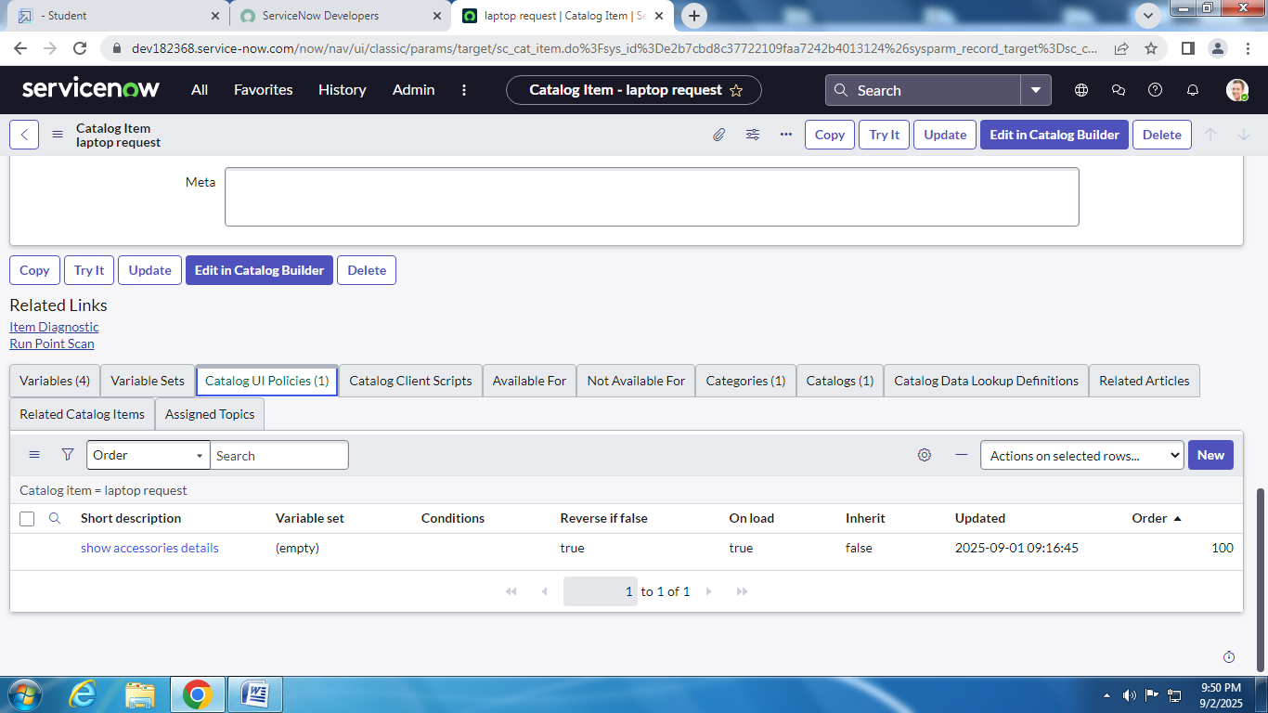

**Create Ui Action**

1.all>>ui actions.

2.create a new ui actions with required details.

**Exporting Changes To Another Instances**

1.all>>local update set>>laptop request>>need to change complete.

2.Export xml>>download the file.

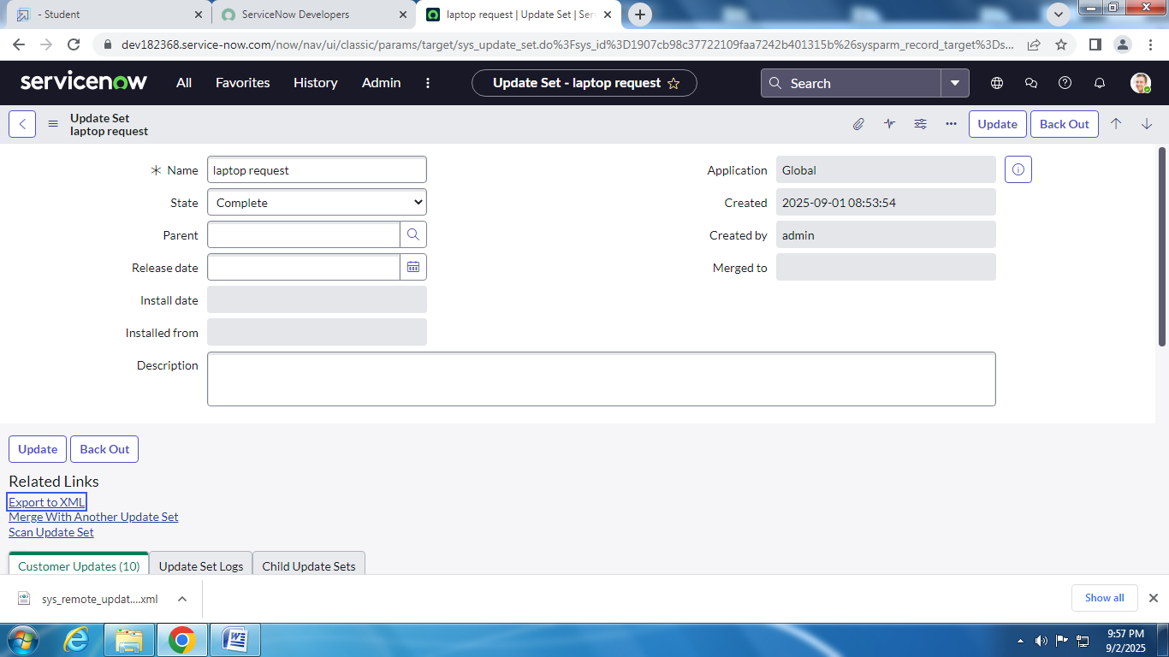

**Retrieving The Update Set**

Open another instance in another browers and import the xml file in it.

Click on the commited update set.

**Test Catalog Item**

Atlast laptop request catalog item is created and it is tested.

Final result is viewed in service catalog>>hardware>>laptop request.

**Conclusion :**

The Laptop Request Catalog project successfully streamlines the process of requesting laptops through ServiceNow. By providing a structured and automated catalog, it reduces manual effort, minimizes errors, and ensures timely approval and delivery. This project enhances user satisfaction, improves IT service efficiency, and demonstrates the importance of using ServiceNow to automate organizational workflows.